**Storyboard**

4.1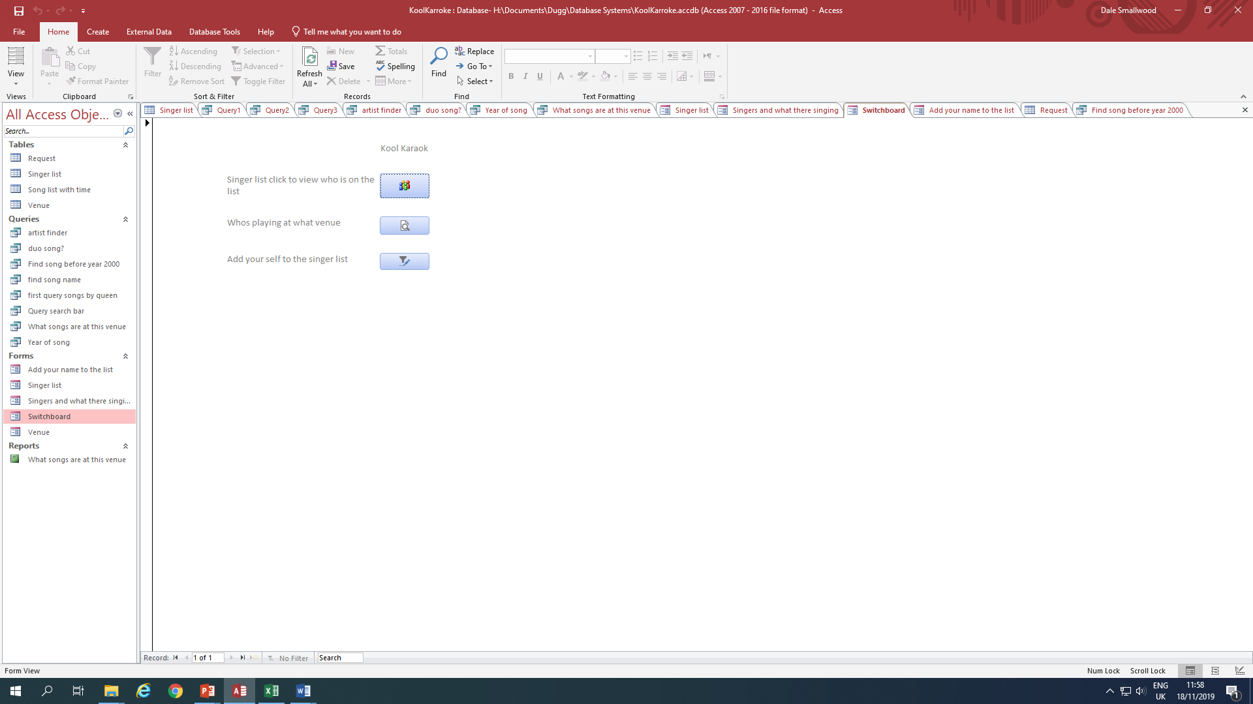

4.2 Issues I had when creating the database

While creating the database I came across a lot of issues such as trying to make the system user-friendly to the physically impaired such as blind, colour blind and dyslexic users as the database results could be more difficult to be found such as typing an artist’s name incorrectly I amended the database to have a ‘like’ function for any word similar such as “Bruno” would come up with all artists with the name Bruno.

While making a set of queries such as the age of the singer a few problems were testing this, as being below the age of 10 would cause an error as they were too young to use the equipment and it would stop the singer from requesting a song, to fix this I created a validation text that said they must be with a parent or guardian to continue. I had the same issue with my mobile phone number as I had set a required amount of numbers but there was already a file that needed filling out too so the only way to fix the issue was to force closing the system and revert the save.

Disability?

New user?

Age?

Experienced?